BOSTON RURAL WEST
NEIGHBOURHOOD POLICING TEAM
AUGUST 2022
WHAT’S BEEN HAPPENING
Seasonal Crime and Anti-Social Behaviour
We have been dealing with increased reports of youth related anti-social behaviour over the summer. Most notably on Parthian Avenue/Winter Way at Wyberton, and in the centre of both Kirton and Swineshead.
The Rural West team have taken action against individuals involved in anti-social behaviour and have issued a number of anti-social behaviour warning letters. As well as this, we have been carrying out joint visits to addresses in partnership with colleagues from social housing landlords and the Boston Borough Council anti-social behaviour team to deal with ongoing issues.
We have been dealing with drug use related incidents at a housing estate in the Wyberton area in partnership with Longhurst Housing Group. This has resulted in several tenancy warnings being issued to residents
Commencing in September, the team will be embarking on several estate walkabouts and residents meetings in partnership with Lincs Housing Partnership. These meetings will be held bi-monthly, firstly in Wyberton and then Swineshead. These events will give residents the chance to come and speak with their local police team as well as partner agencies and raise any issues in their area

YOUR LOCAL TEAM
bostonruralwest@lincs.pnn.police.uk
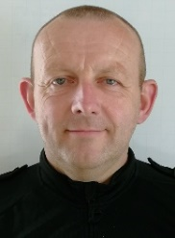 |  | 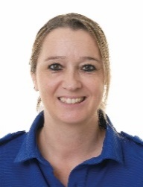
PC Jon Thornton  07973 847073 | PCSO Neil Williams  07976 946367 | PCSO Esther Smyth  07973 846820

FORTHCOMING ENGAGEMENTS
Estate walkabout, Parthian Avenue, Wyberton – 5th September 1.00pm – 2.30pm
Residents meeting, The Orchards, Wyberton – 6th September 1.30pm-2.30pm

LOCAL PRIORITY
Every three months, we listen to your concerns and look at recent crime statistics to shape the things we will concentrate on for the next three months. Our priority(s) for this quarter is:
Seasonal Crime and Anti-Social Behaviour
We will be targeting types of crimes and anti-social behaviour which traditionally see a peak at this particular time of year.

