BOSTON RURAL WEST
NEIGHBOURHOOD POLICING TEAM
SEPTEMBER 2022
WHAT’S BEEN HAPPENING
Seasonal Crime and Anti-Social Behaviour
We have been dealing with reports of youth related anti-social behaviour. Most notably on Parthian Avenue at Wyberton, and at the Town Hall and Graves Park in Kirton.
The Rural West team have taken action against individuals involved in anti-social behaviour and have issued a number of anti-social behaviour warning letters. As well as this, we have been carrying out joint visits to addresses in partnership with colleagues from social housing landlords and the Boston Borough Council anti-social behaviour team to deal with ongoing issues.
In response to numerous reports of drug related activity in the area, officers carried out a drugs warrant at a property on Craven Avenue, Kirton on 17th September. A quantity of drugs were found at the property along with cash and weapons. Two people were arrested for these offences. The warrant was obtained as a result of information passed to the local Neighbourhood Policing Team. The police will always look to take positive action when receiving information from our local community, and we would like to thank the people of Kirton for coming forward and providing information to obtain a successful outcome.

YOUR LOCAL TEAM
bostonruralwest@lincs.pnn.police.uk
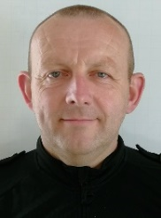 | 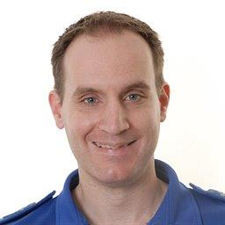 | 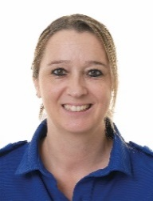
PC Jon Thornton  07973 847073 | PCSO Neil Williams  07976 946367 | PCSO Esther Smyth  07973 846820

FORTHCOMING ENGAGEMENTS
Estate walkabout, Parthian Avenue, Wyberton – 4th October 1.00pm – 2.30pm
Residents meeting, Swinfields, Butlers Way, Swineshead – 27th October 1.30pm-2.30pm

LOCAL PRIORITY
Every three months, we listen to your concerns and look at recent crime statistics to shape the things we will concentrate on for the next three months. Our priority(s) for this quarter is:
Seasonal Crime and Anti-Social Behaviour
We will be targeting types of crimes and anti-social behaviour which traditionally see a peak at this particular time of year.

